ST. XAVIER’S COLLEGE

**(Affiliated to Tribhuvan University)**

**Maitighar, Kathmandu**



**Database Management System**

**Lab Assignment #11**

**SUBMITTED BY:**

**Apil Neupane**

**013BSCCSIT008**

**SUBMITTED TO:**

|  |  |
| --- | --- |
| **Er. Sanjay Kr. Yadav**  **Lecturer** |  |
| **Department of Computer Science** | |

Submission Date: 9thOctober 2015

Create Table Farmer

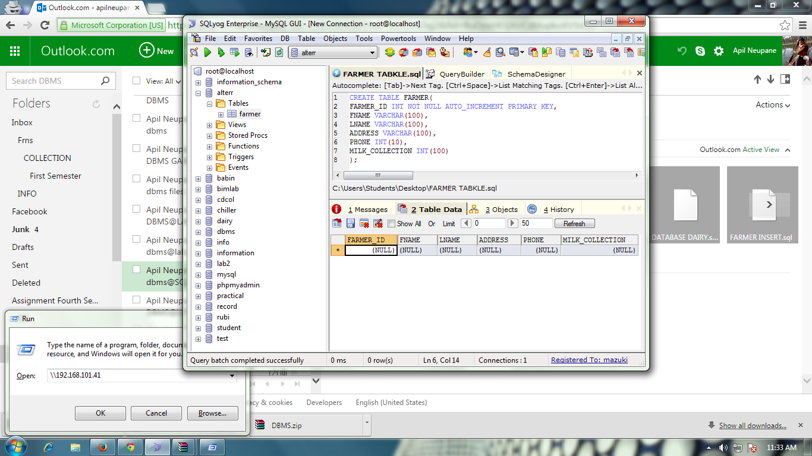

Insert Values into Farmer

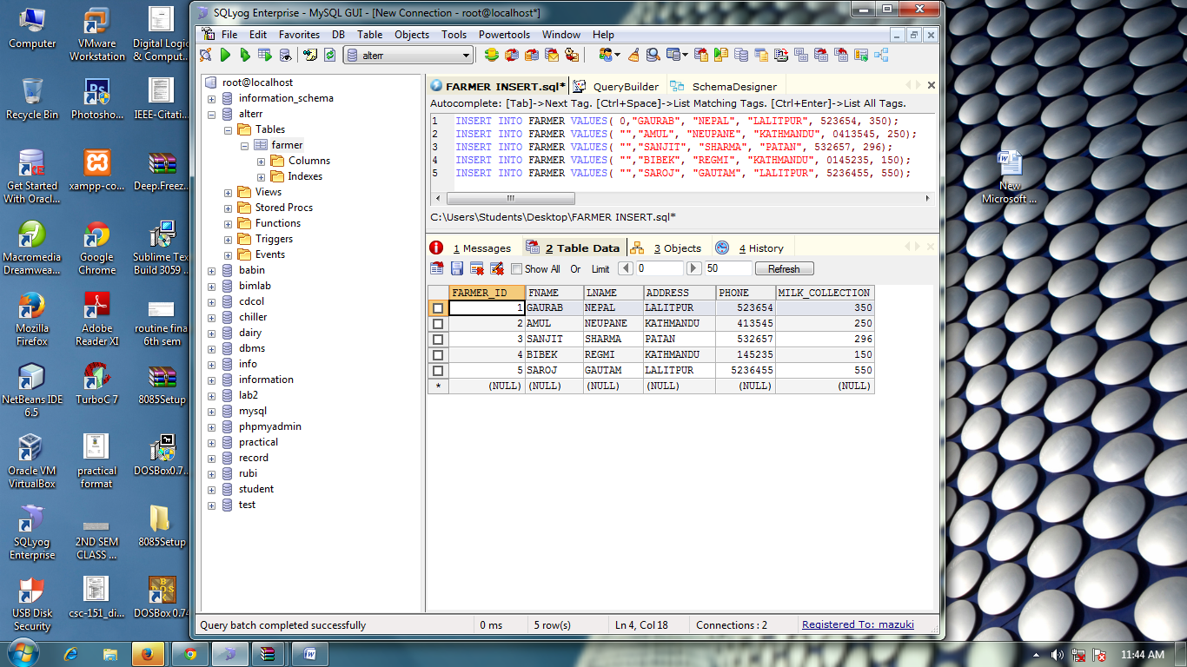



Alter Table Farmer

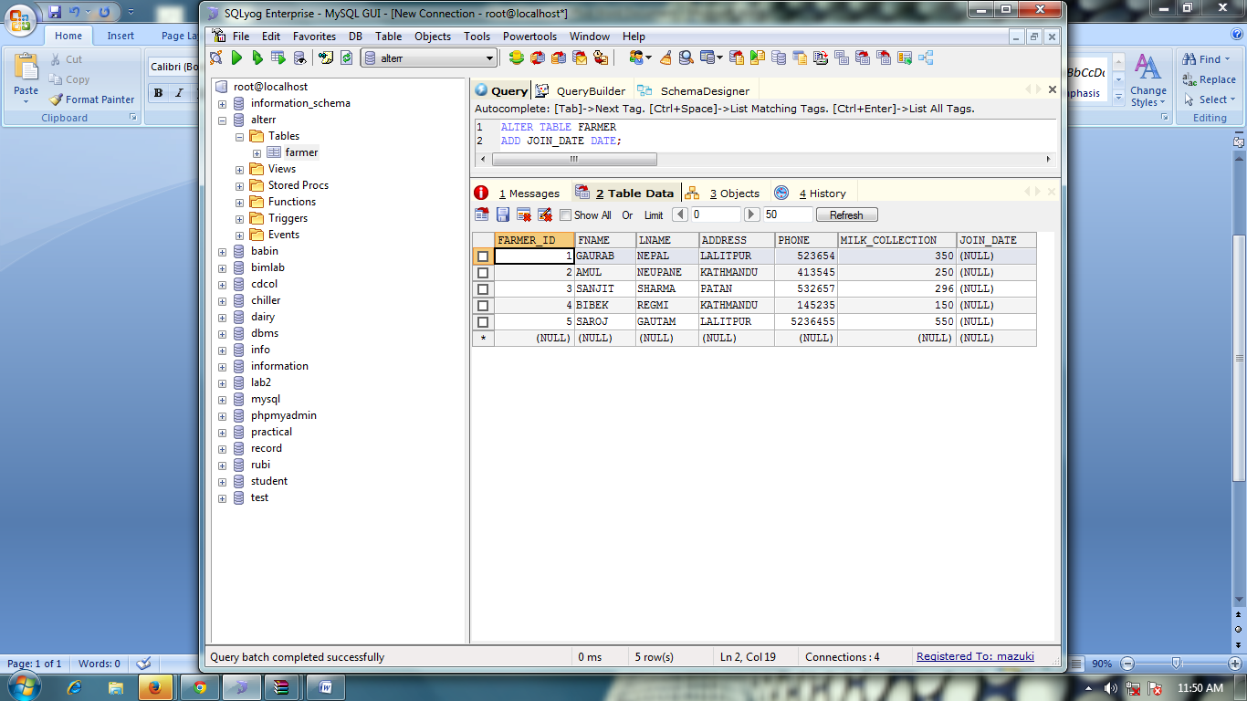

Update

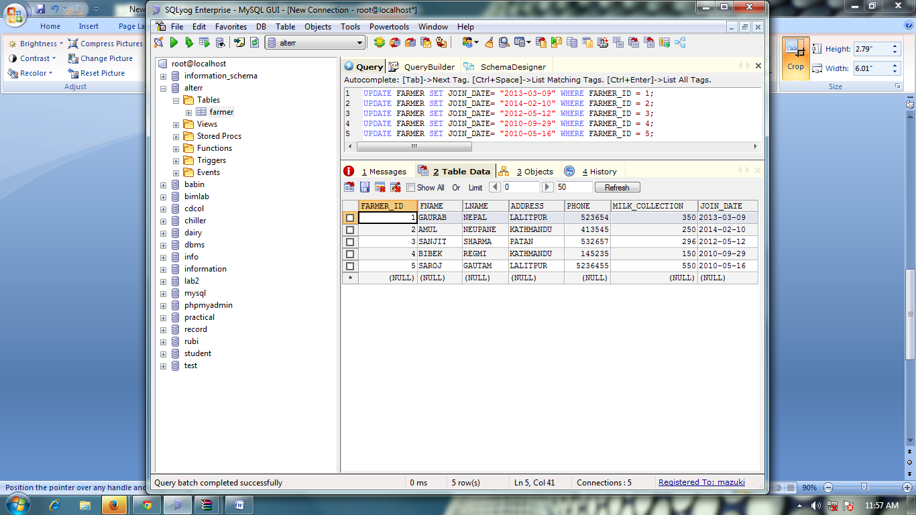

Update Datatype:

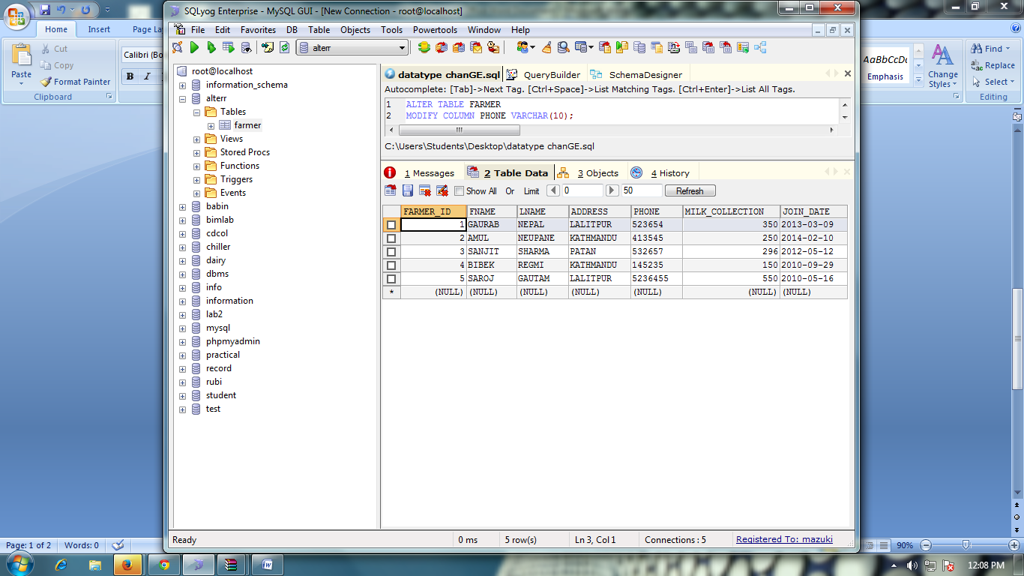

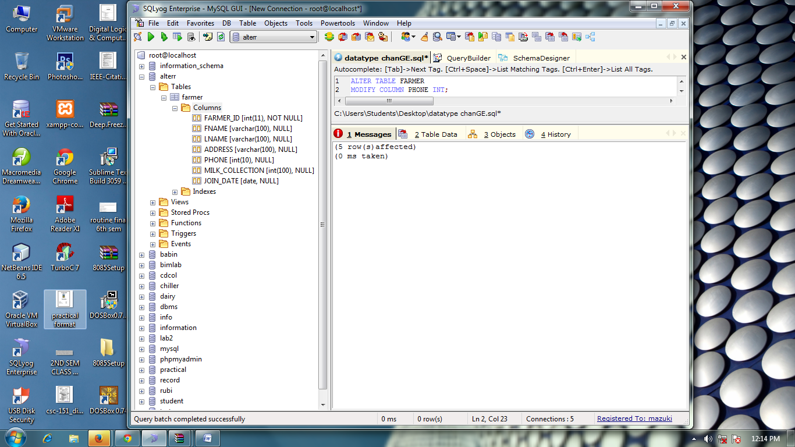 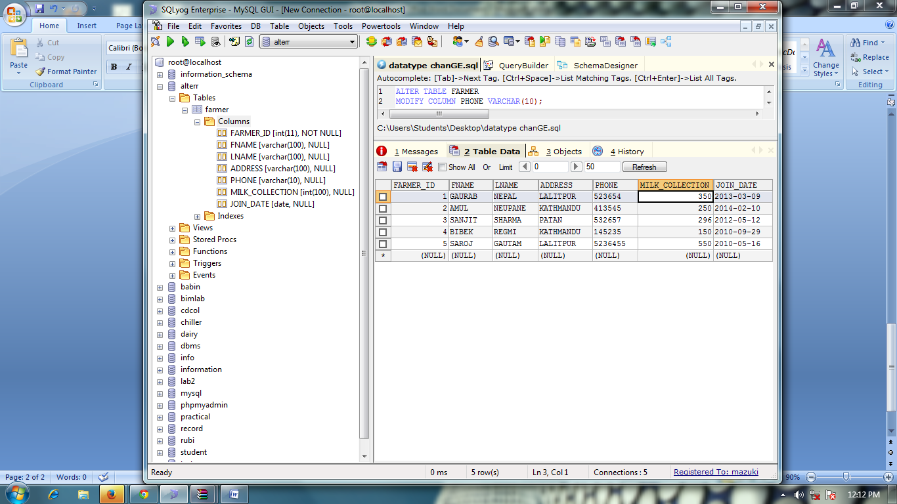

Create table Bonus

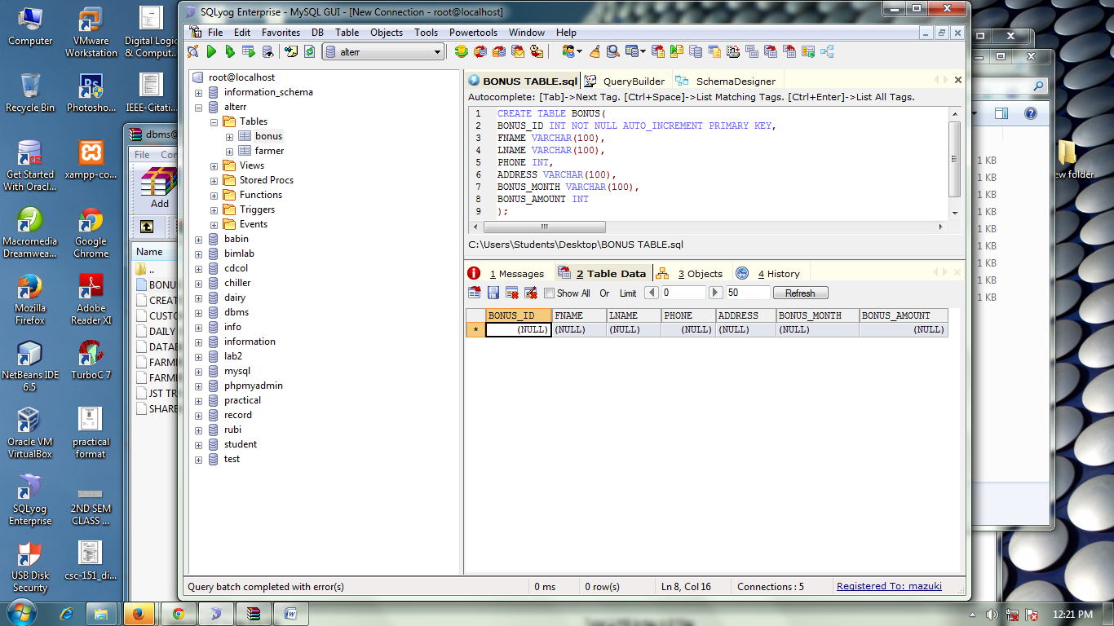

Insert Values into BONUS

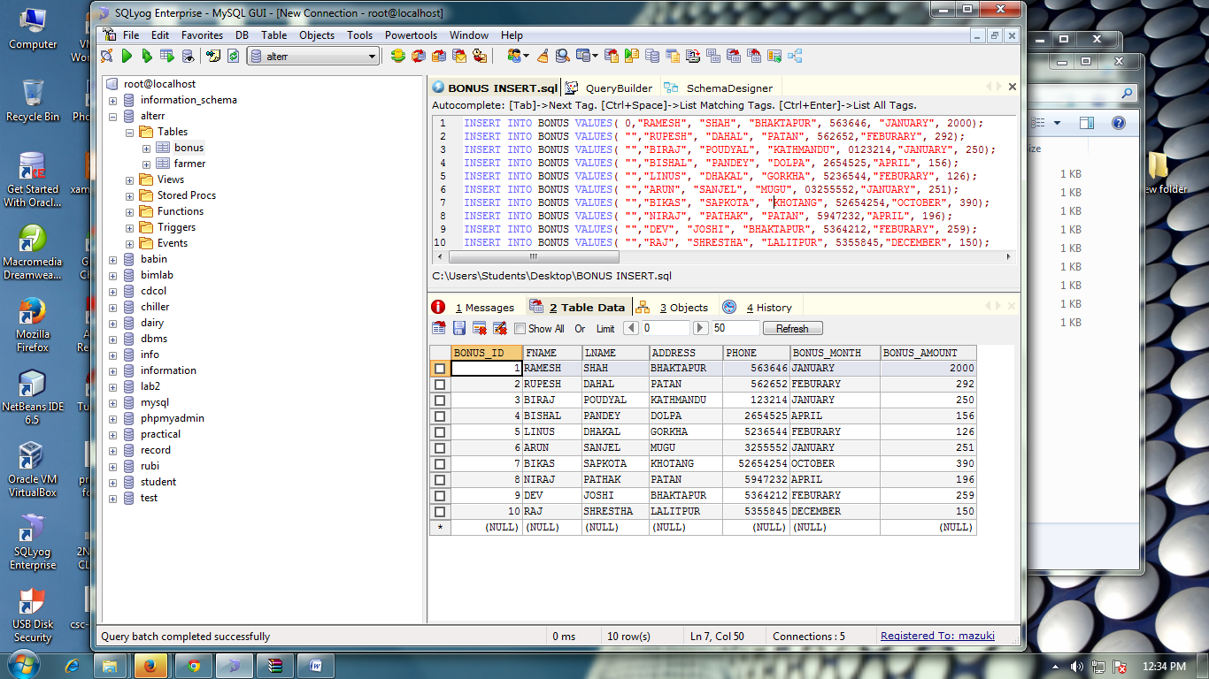

Drop Table

